|  |
| --- |
| Embedded Systems Lab Experiment 7 |
| Analog to Digital Conversion using AtMega32 |
| Program an AtMega32 to convert analogue voltage signal into its digital equivalent |

|  |
| --- |
| Jitbitan Baroi  3-10-2024 |

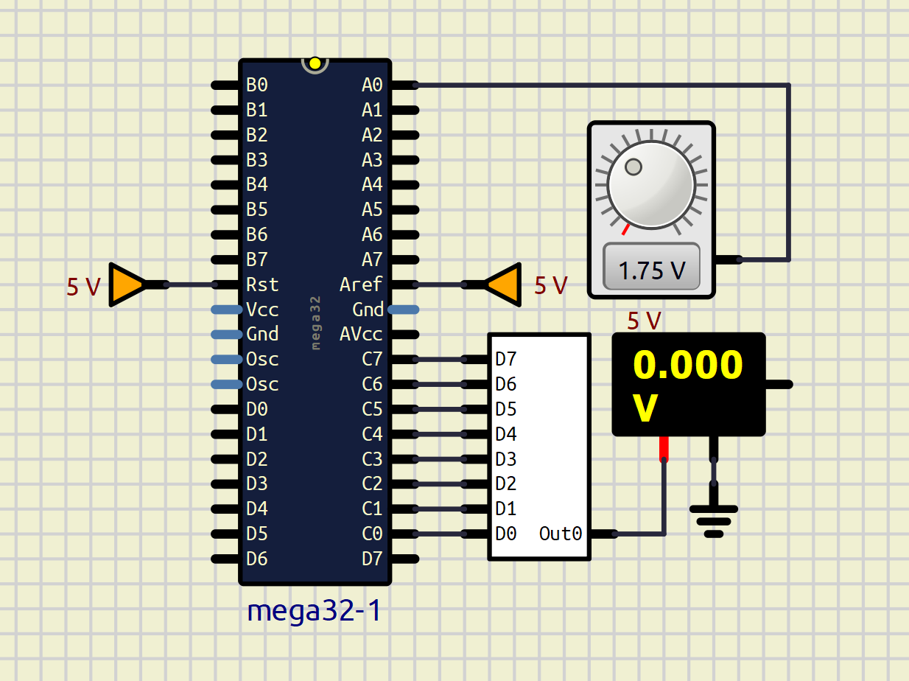

Schematic used for ADC conversion at pin A0 and displaying the digital equivalent through a DAC from PORTC

|  |
| --- |
|  |
|  |
|  |

Three different voltage signals are applied at pinA0 and the corresponding the conversion is shown in voltmeter (error is due to the discarding of the last two bits)